
STATE UNIVERSITY OF MOLDOVA 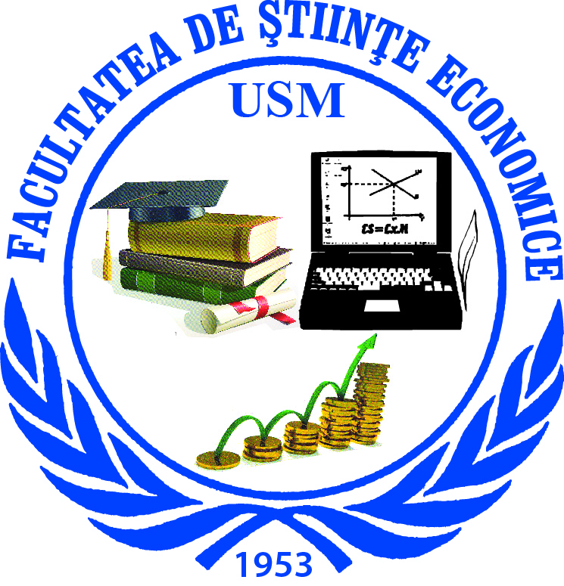

FACULTY OF ECONOMIC SCIENCES

Str. A. Mateevici, 60, Chişinău, MD-2009, Republica Moldova, tel: (+373 22) 57-78-03,
(+373 22) 57-74-60, E-mail: fse.conferinta2014@mail.ru

INVITATION

Dear colleagues,
FACULTY OF ECONOMIC SCIENCES
has the honor to invite you to attend
the 9th International Scientific Conference
„Policies and mechanisms of innovation and development of economic,
financial and social processes at national and international level”,
which will be held between October 31 – November 01, 2014

Sections of the Conference:
Section I: The impact of the financial and banking strategies on innovation and development of economic and social processes.
Section II: Politiques et mécanismes d`innovation pour le développement des Petites et
Moyennes Entreprises (PME) des Pays d'Europe Centrale et Orientale (PECO). (francofonă)
Section III: Theoretical and practical aspects in accounting, auditing and information systems in the context of the current regulations.
Section IV: Opportunities of Promotion of Economic Vector.
Section V: Management of innovation processes in the context of ensuring competitive benefits and economic growth.

The Conference will be held in the Central Block of the State University of Moldova, mun. Chişinău, str. A. Mateevici, 60.
The papers may be submitted in the following languages: Romanian, English, French and Russian. All papers will be peer reviewed and those accepted will be published in Conference materials.
Important dates
Registration: paper title, author(s), academic title and scientific position, institution, abstract, e-mail, phone. | May 15, 2014
Paper submission deadline | September 15, 2014
Conference | October 31 –November 01, 2014

- The paper can be sent to the e-mail: fse.conferinta2014@mail.ru. Contact phonee: (+373 22) 57-74-60
- Transportation and accommodation expenses will be supported by the participants.
- For the presentation papers will provide technical assistance.

Galina ULIAN
Dean , PhD, professor

REGISTRATION FORM
INTERNATIONAL SCIENTIFIC CONFERENCE
October 31 – November 01, 2014

Author(s), academic title and scientific position, institution.
Paper title
Abstract
e-mail, phone
Section

